Setting Up OpenSpecimen Catalog Account
- Once an IU Coordinator has reviewed the Data Agreement that was completed by an interested researcher, they will create an OpenSpecimen Catalog account for the researcher.
- After the account is created, the researcher will receive 3 emails from do-not_reply@krishagni.com:
  - Email 1 Subject Line: [OpenSpecimen Reports]: Your profile details for OpenSpecimen
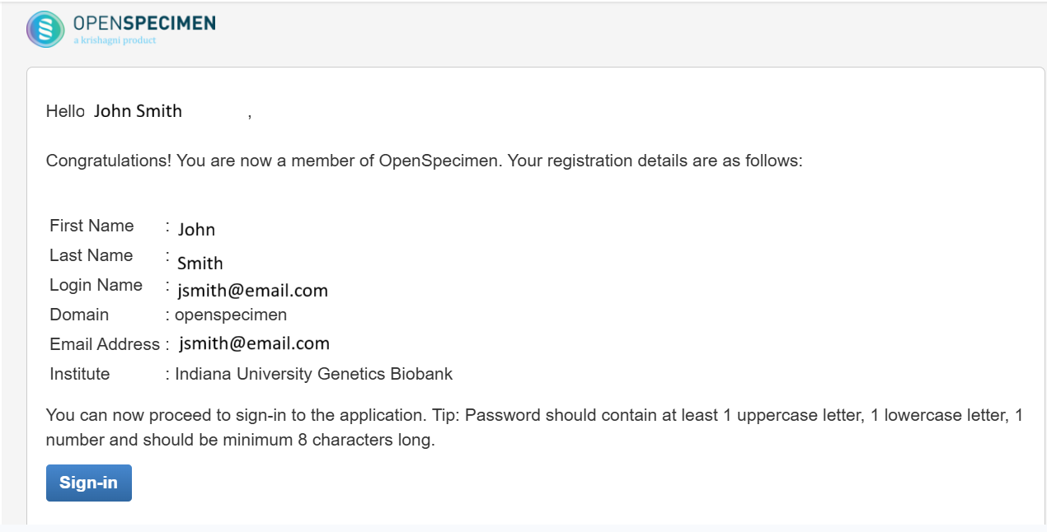
  - Email 2 Subject Line: [OpenSpecimen Reports]: Your secret OTP code is generated
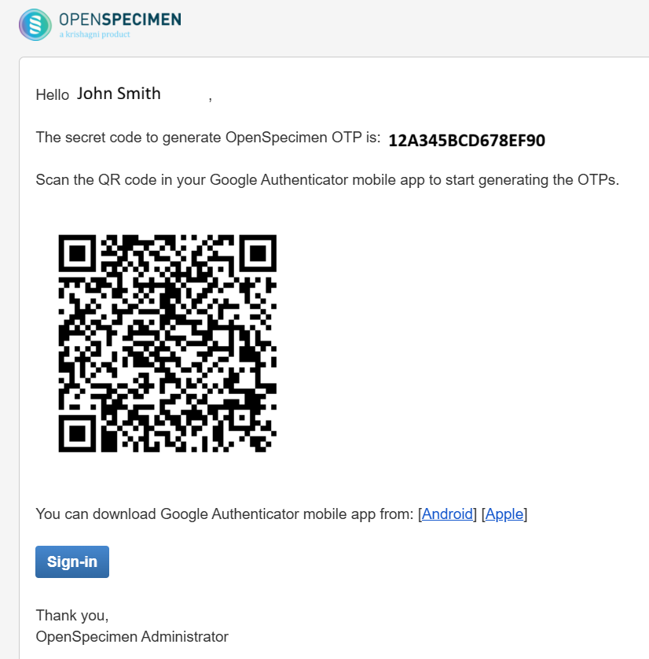
QR CODE
  - Email 3 Subject Line: [OpenSpecimen Reports]: User [Researcher Name] role has been updated
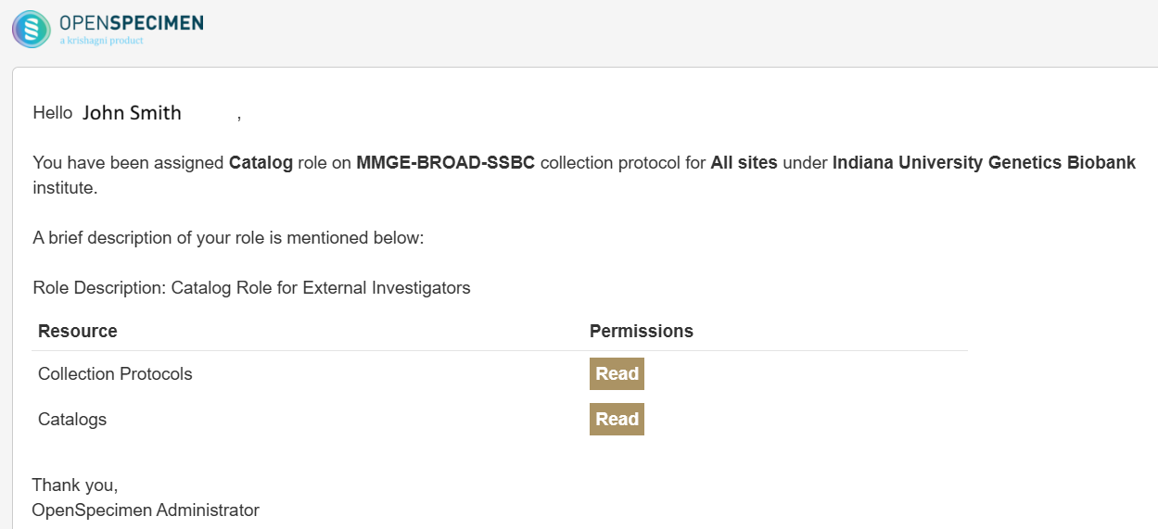
- Locate the “Profile Details” email that starts with “Congratulations!” in the body of the email. (See image in step 2a.)
- Click on the blue “Sign-In” button in the bottom left corner of the email.
- A new window will pop up in your browser with a screen that shows a “Reset Password” box.
  - Login Name: Type in the email address that received these OpenSpecimen emails.
  - Password: Type in a password that has at least 1 uppercase letter, 1 lowercase letter, 1 number, and is a minimum of 8 characters long.
  - Confirm Password: Enter the information that was created in the Password field.
- Click the blue “Reset Password” button when done.
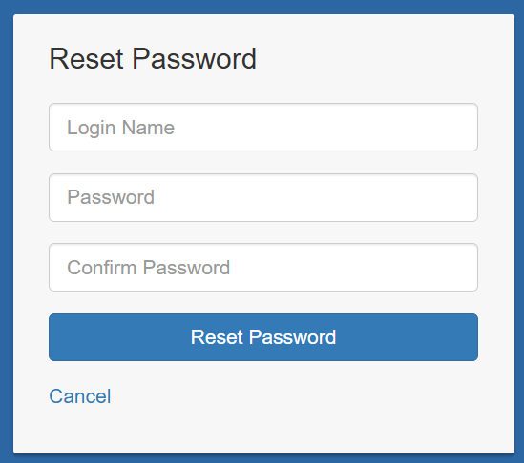
- A box should next appear stating the password has been set. Click on the blue link named “Return to the sign in page”.
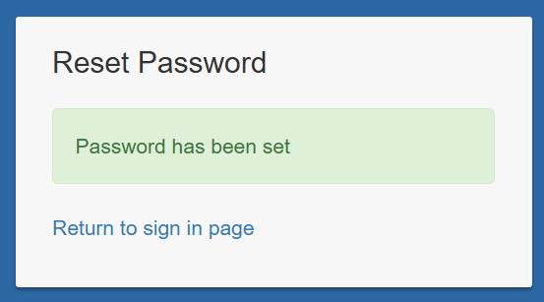
- Before logging in to OpenSpecimen locate the “OTP Code” email that has a giant QR code in the body of the email. (See image in step 2b.)
- On your Android or Apple phone, download Google Authenticator, Duo Mobile, or similar dual-authentication app, if one is not already downloaded.
- Open Google Authenticator, Duo Mobile, etc., and scan the giant QR code from the OPT Code email with your phone. This will establish the account that automatic OTP codes will generate through the app.
  - If using Duo Mobile, there should be an “Add+” sign to click on and under the “Add Account” there will be a “USE QR CODE” option. Use this option to scan the QR code in the OTP code email.
  - If using Google Authenticator, there will be a blue circle in the bottom right corner of the phone screen with a QR icon in the middle. Click on this blue circle and scan the QR code in the OTP code email.
- After setting up the app for the OTP codes, return to the OpenSpecimen sign in page.
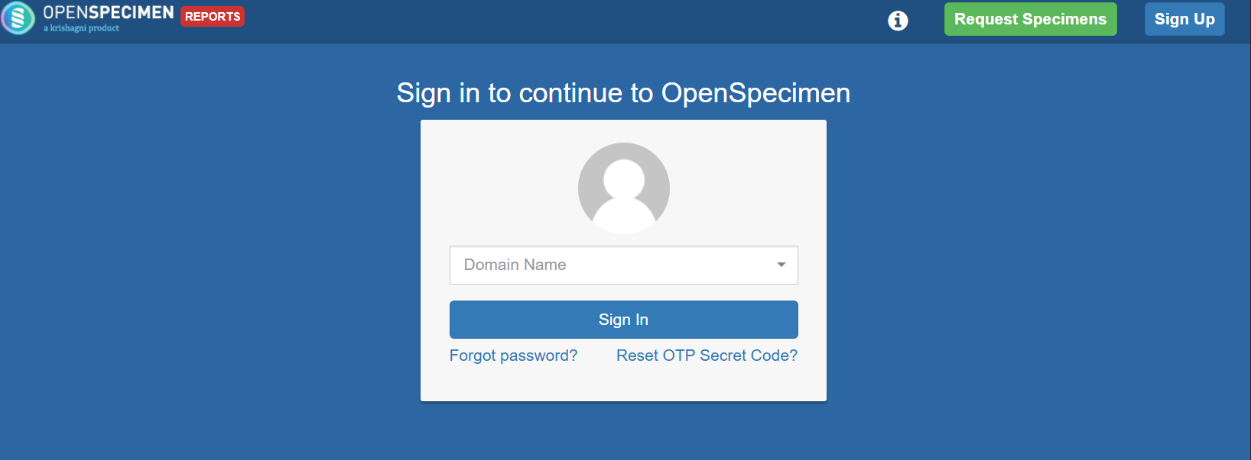

- Click on the Domain drop down menu and select “openspecimen”.
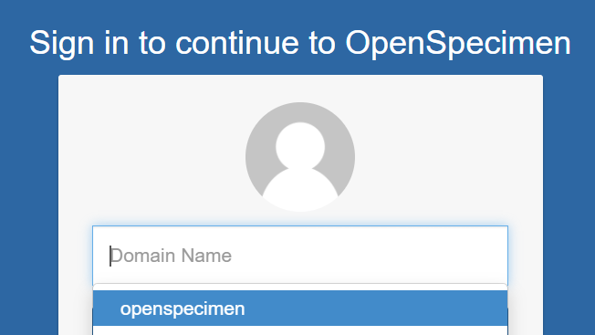
- Fill in the following information:
  - Login Name: email address associated with OpenSpecimen account
  - Password: newly created password
  - OTP: this is the code that is automatically generated from the dual-authentication app that was downloaded to the phone.
    - Google Authenticator: 6-digit code
    - Duo Mobile: 3-digit code
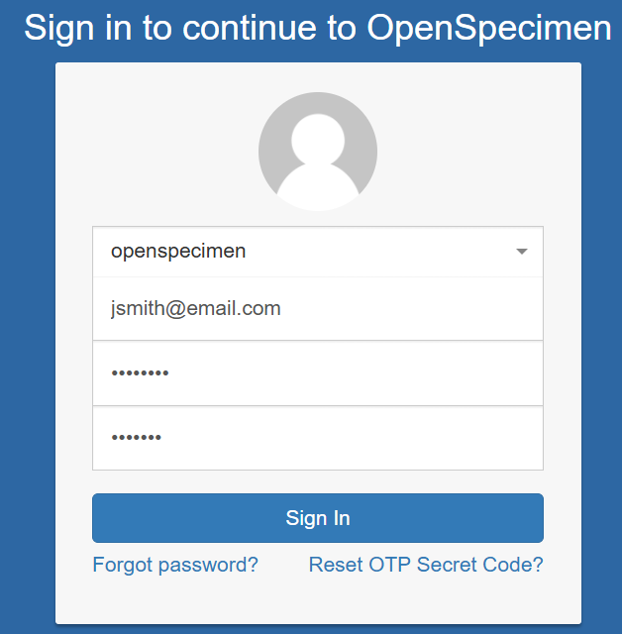
Login Name
Password
OTP Code
- Click on the blue “Sign In” button. The OpenSpecimen homepage should appear.
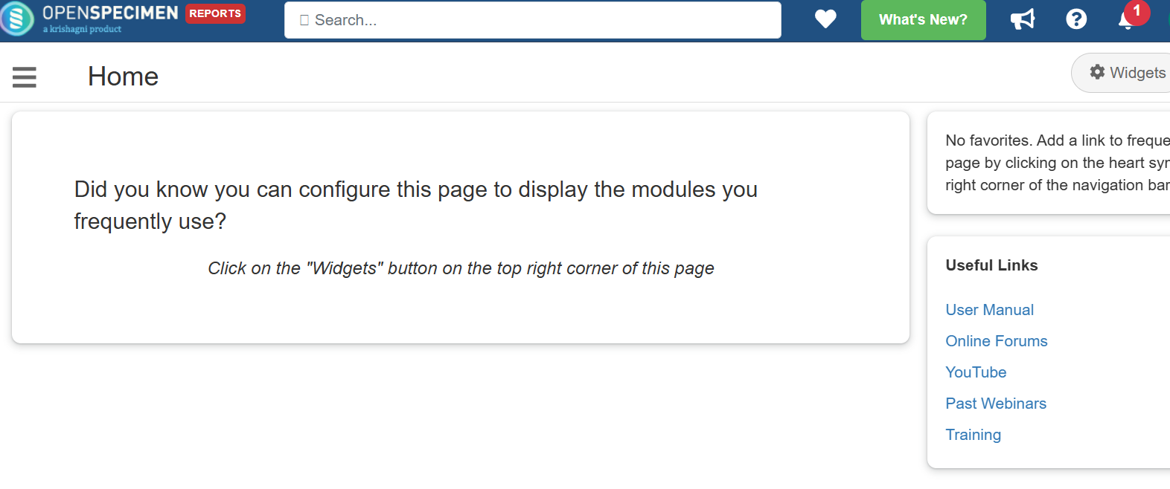
- Click on the menu button located in the top left corner of the page next to the word “Home”. When the options appear, click on “Catalogs”.
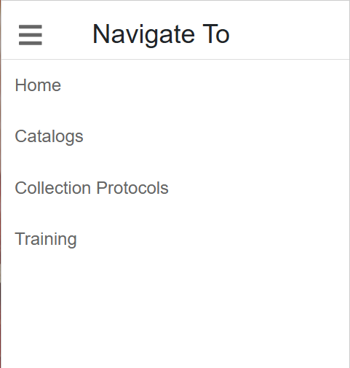
- When the Catalogs page loads, there should be a list of all the different catalogs that the researcher has granted access. Click on the preferred catalog from the list.
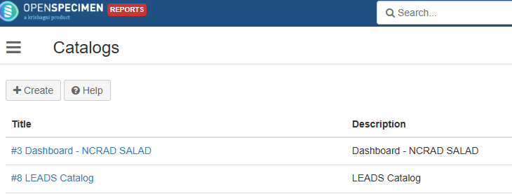
- A Requests page will load. Click on the gray “View Catalog” button at the top left of the screen.
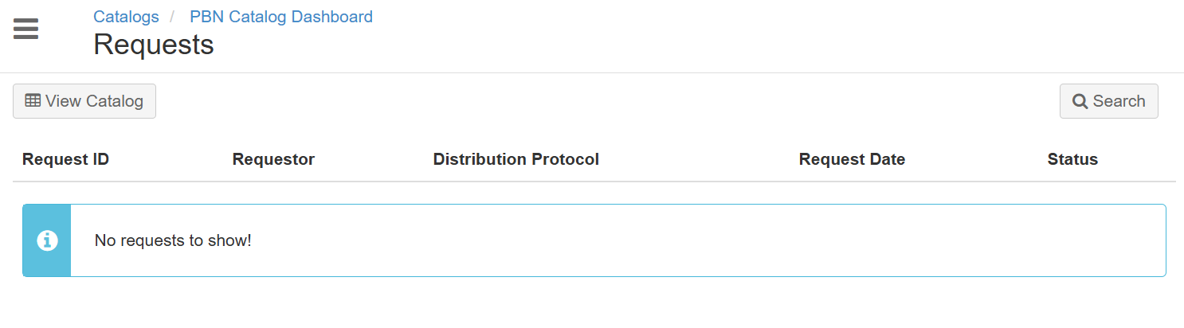
- This will take the researcher to the “Data at a Glance” page for the selected catalog to view what samples are available. Click on the blue “View Catalog” button in the top right of the screen to start selecting samples.
